Please complete the details below and then email the completed form to warranty@crowcon.com to obtain a returns number (eg SERQ1234).
Once a SERQ number has been issued you should add it to this form and ship the items to the address shown below. Please tick if any extended warranty applies*.
A copy of this completed Warranty Claim Form must be returned with the items; failure to do so is likely to result in delays with the processing of your claim.
Only items listed on this form will be processed: any additional products or spares returned without prior approval will be rejected and returned.
Terms and conditions apply: see our Warranty page on www.crowcon.com.
Company Name |  |  |  | Contact name |  |  |  | E-Mail/Telephone No | Account No.
Fictitious Safety Co Ltd |  |  |  | Robert Robertson |  |  |  | r.robertson@fictitioussafety.com | FIC001
Customer Return Address:  If warranty is rejected please  (delete as appropriate) |  |  |  | 172 New Road, Business Park South, Oxfordshire, OX7 7QQ, United Kingdom
 |  |  |  | Return the items to me at my cost / dispose of the items on my behalf / provide a repair quotation*
Are You Returning: Detector or Spare | Product Type | Part Number | Description of item | Instrument Serial No | Spare Part  Date Code | Original Sales Order No. | Fault Reported |  |  | *Ext Warranty?
Detector | Gas Pro |  | Gas Pro IR | 421300/02-004 |  | 555222 | Unable to read CO2 sensor on display |  |  | n/a
Detector | Triple Plus + |  |  | 2560036056 |  | 555444 | Alarm lights and sounder not working |  |  | n/a
Spare | T4 | SS0501 | Oxygen Sensor | W256110/01-010 | 078 | 555999 | Oxygen level 2.4% vol |  |  | n/a
Spare | Gasmaster III | S012016 | Display PCB | GMS555000/01-001 |  | 555001 | Display faulty |  |  | N/a
Detector | T4 |  | T4 | W256110/01-011 |  | 555101 | Unable to calibrate |  |  | 3EW
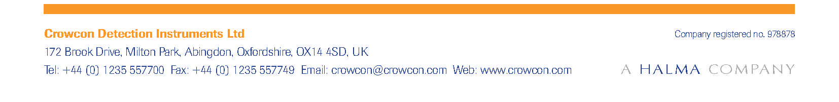

SERQ No. (supplied by Crowcon)

Warranty Returns:
Crowcon is committed to providing an efficient warranty service to our customers and agents. The following guidelines must be followed to ensure we are able to process your application as quickly and effectively as possible.

A copy of the completed Warranty Claim Form must be returned with the items; failure to do so is likely to result in delays with the processing of your claim.
Please provide detailed information on the fault condition and tests you have carried out to confirm that the item is faulty; this will assist us to make a quick diagnosis.
Any spare part, sensor, component or accessory returned must be documented with the serial number of the instrument the part came from, or when it was purchased. The warranty on components or spare parts (including parts replaced during a warranty repair) is limited to the original warranty of the instrument from which the part came. Warranty claims for parts purchased as spares must be accompanied by the sales order number for the purchase as the shipment date represents the start-point for the spare part warranty.
Returns without correspondence or confirmation of age may be rejected.
Items must be returned in a complete / fully assembled condition and individually packed securely, preferably in the original packaging.
All electronic components (including sensor modules) must be returned in individual sealed ESD-protected bags.
Individual batteries should have the wires/contacts insulated when packed.
Please indicate by entering a tick against the affected product whether any extended warranty has been purchased.
When returning Xgard sensor modules, the entire assembly (PCB, sensor and moulding) must be returned fully assembled. Connection pins should have a carrier PCB fitted, if this part is unavailable the pins must be adequately protected from being damaged during shipment.
Crowcon reserve the right to reject warranty if returned items are inadequately packaged.

